Desired Market:

<https://www.sparkfun.com/products/retired/18383>

Higher level Prototype kits with built in user interface hardware. These solutions are worse, but its customrers are our target market

Competitor:

<https://www.adafruit.com/product/5032>

<https://shop.m5stack.com/products/esp32-basic-core-lot-development-kit-v2-7>

A different solution that builds the whole device instead of just the user interface, and restricts options. Not viable for prototyping stages of development of IP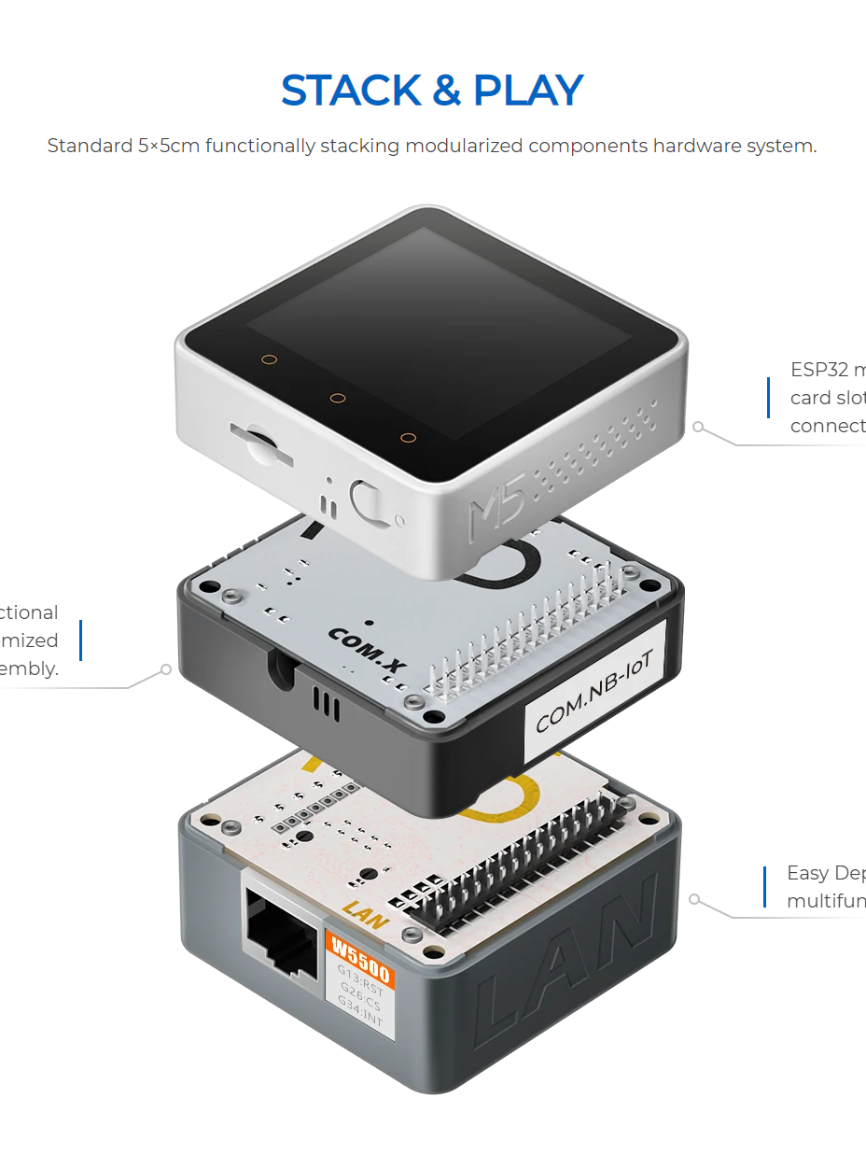

Emerging technologies:

<https://www.nxp.com/design/designs/nxp-rapid-iot-prototyping-kit:IOT-PROTOTYPING>

<https://www.allaboutcircuits.com/projects/interface-an-lcd-with-an-arduino/>

The ease with which low skill users can build a user interface with open source hardware like Arduino

Abisha’s Research

S-Tier Companies from the Career Fair List (that need a UI)

BAE Systems

Brock Solutions

Device Solutions

DMC Inc

Garmin

Tangentially Related ee/cpe companies

AMD

Arm, inc.

Cadence Design Systems

Corning

Stretch Companies

industrial scale/electromechanical systems: ABB\*, AlfaLaval\*, ARM Group\*, Caterpillar\*, Delta Electronics Americas

Emerson is a competitor for the above companies

Alston & Bird (for the patents)

BD

Cisco

Covar (military)

<https://tslproducts.com/products/tsl-control/control-glue-overview/>

<https://www.pasco.com/products/interfaces-and-dataloggers/ui-5000>

<https://learn.sparkfun.com/tutorials/i2c/all>

<https://learn.sparkfun.com/tutorials/serial-communication>

<https://discountpoolmart.com/jandy-universal-controller-user-interface-r3008800>